
National College of Computer Studies
Paknajol, Kathmandu

Report on Library Management System

Submitted by: Submitted to:
Suraj Timsina Khusbu Kumari Sarraf
Programme: BSc. CSIT 3rd semester Lecturer
Email: surajtimsina321@gmail.com

Declaration
I hereby declare that the project work entitled “Library Management System” submitted to Institute of Science and Technology, Tribhuvan University, Kathmandu. National College of Computer Studies, Kathmandu, is for the degree that is submitted in partial fulfillment of requirements for the degree of Bachelor of Science in Computer Science and Information Technology (BSc.CSIT). This report contains all the original research and analysis with some information taken from other resources which are properly cited. This project work has not been submitted to any other university or institution for the award of any degree or diploma.

Acknowledgment

This report is my assignment as a partial fulfillment of project work course for the requirement of Bachelor of Science in Computer Science and Information Technology (BSc.CSIT). I have taken this opportunity to express my respect and gratitude to my respected teacher Mrs. Khusbu Kumari Sarraf for her valuable guidance in making this project a reality. I am thankful for their constant support and encouragement and valuable guidance and encouragement throughout this project completion period. I am also thankful to the lab teacher Samrat Singh for his help during the completion of the project. I would like to present my teachers gratitude for their guidance, good advice and honest reviews in this entire project session. Project has been completed under the intensive and genuine guidance of the National College of Computer Studies.

Suraj Timsina
National College of Computer Studies
Date: April, 2024
Abstract

The "Library Management System " project is designed to provide an efficient and organized solution for managing library resources using the C++ programming language. This project focuses on the implementation of fundamental programming concepts, file handling, and data structures, to create a robust system that simplifies library operations. By addressing real-world challenges in library management, this project provides a holistic understanding of software development principles, database management, and user interface design. The software is implemented in C++ programming language and operates through a console interface.

Table of contents

1. Introduction 1
1.1 Background 1
1.2 Purpose 1
2. Objectives 1
3. Problem Overview 1
3.1 Current Challenges 1
3.2 Importance of Automation 2
4. Methodology 2
4.1 System Design 2
4.2 Database 2
4.3 User Interface 2
5. System Implementation 2
5.1 Features 2
5.2 Implementation Tools 3
5.3 Testing 3
6. System design and development 3
6.1 My Source Code 3
6.2 Output 7
7. Conclusion 9
8. Reference 10

Table of Figures
Figure 1:Different Structures 3
Figure 2:Function Declaration 4
Figure 3:Main Function 4
Figure 4:Switch case 5
Figure 5:File handling 6
Figure 6:Function Definition 6
Figure 7:Main Menu 7
Figure 8:Authentication & Option Selection 7
Figure 9:Book Record 8
Figure 10:User Record 8
Figure 11:Book Issue 8

Introduction

1.1 Background
Libraries play a crucial role in providing access to a vast repository of knowledge. The efficient management of library resources is essential for ensuring easy accessibility and optimal utilization. The Library Management System (LMS) in C++ aims to streamline the operations of a library, facilitating efficient book management, user registration, and other essential tasks.[1]

1.2 Purpose
The purpose of this project is to develop a robust and user-friendly Library Management System using C++. This system aims to automate various library tasks, enhancing the overall efficiency of the library staff and improving the experience for library users.[2]

Objectives
The main objectives of the Library Management System project are:

• Efficient management of books and users.
• Secure authentication and access control.
• Smooth book issuing and returning processes.
• User-friendly interface for seamless interaction.
• Accurate date validation and fine calculation.

Problem Overview

3.1 Current Challenges
The manual management of library operations is prone to errors, time-consuming, and may lead to inefficiencies. Common challenges include:
- Inaccurate record-keeping.
- Difficulty in tracking book availability and overdue fines.
- Inefficient user registration processes.
- Lack of real-time information on library resources.

3.2 Importance of Automation
Automating the library management process using C++ will address these challenges, leading to a more streamlined and error-free system.

4. Methodology

4.1 System Design
The Library Management System will be designed using C++. The system will consist of functions for add/editing books, user information with appropriate data structures for efficient storage and retrieval of information.

4.2 Database
A simple database system, either file-based or using SQLite, will be implemented to store information about books, users, and transactions. This will ensure persistent storage and easy retrieval of data.

4.3 User Interface
The system will have a console-based user interface for simplicity and ease of use. Users will interact with the system through a series of menus for tasks such as book search, add book, book list.

System Implementation

5.1 Features
The Library Management System will include the following features:
- User registration and authentication.
- Book issuance and return functionality.
- Validates dates for issuing and returning books.
- Charge fines for late returns.

5.2 Implementation Tools
The project will be implemented using C++ programming language. The choice of C++ is based on its efficiency, performance, and widespread use in system-level programming.

5.3 Testing
Thorough testing will be conducted to ensure the reliability and correctness of the system. Unit testing and integration testing will be performed to identify and fix any bugs or issues.

System design and development

My Source Code
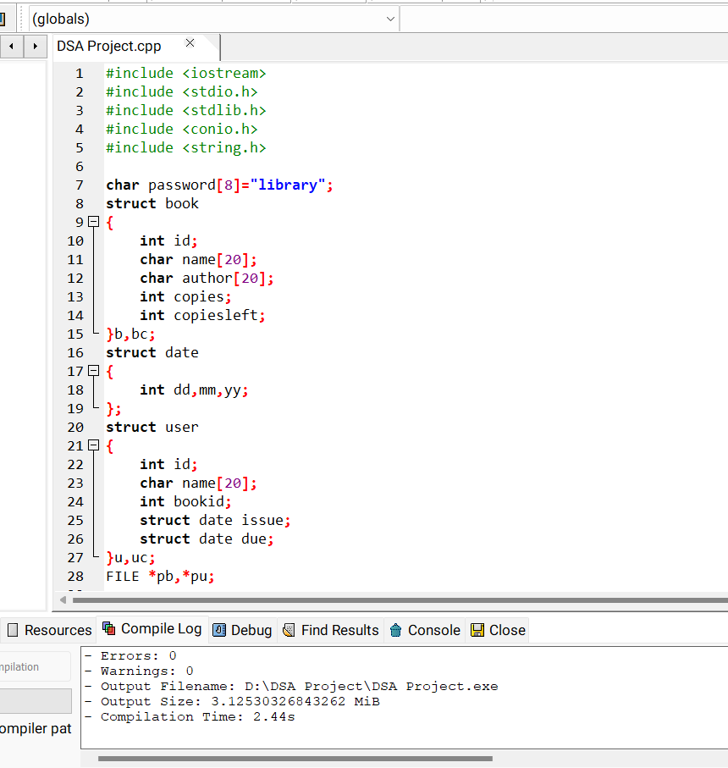
Figure 1:Different Structures

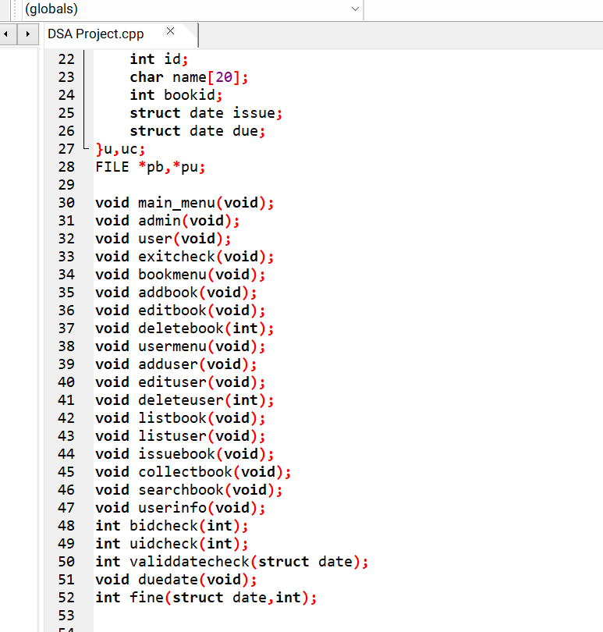
Figure 2:Function Declaration

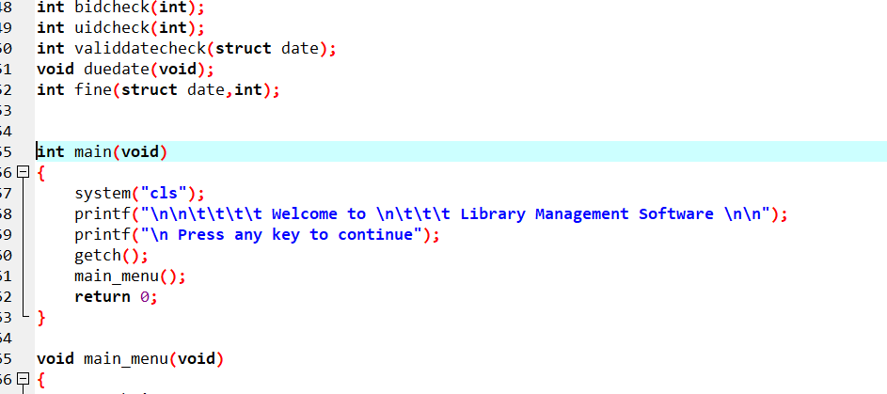
Figure 3:Main Function

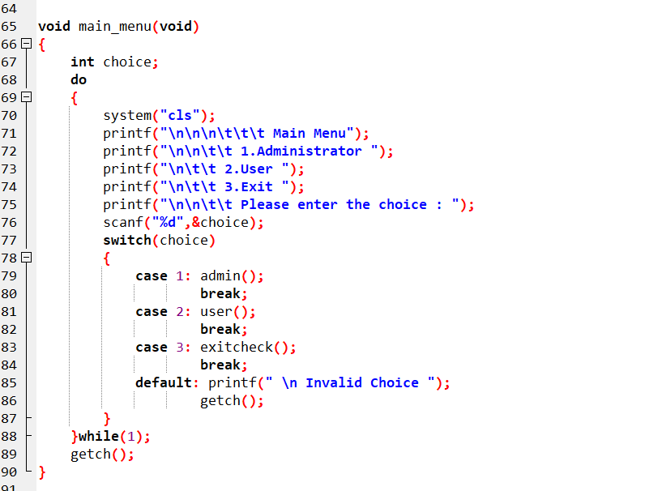
Figure 4:Switch case

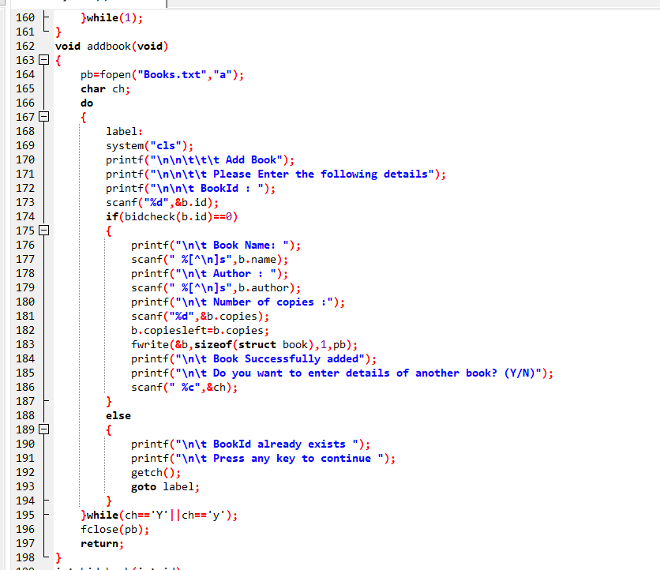
Figure 5:File handling

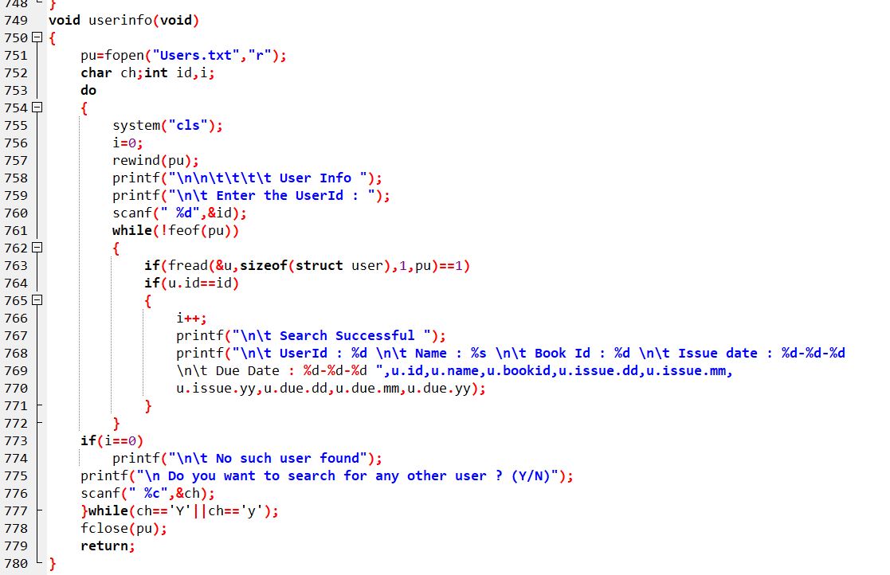
Figure 6:Function Definition

6.2 Output
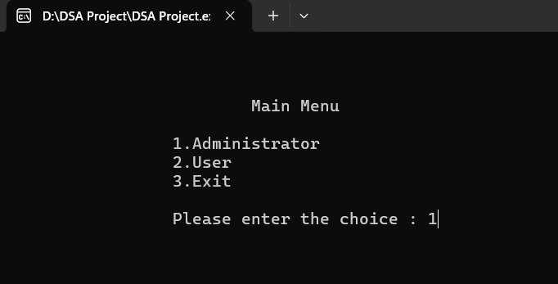
Figure 7:Main Menu

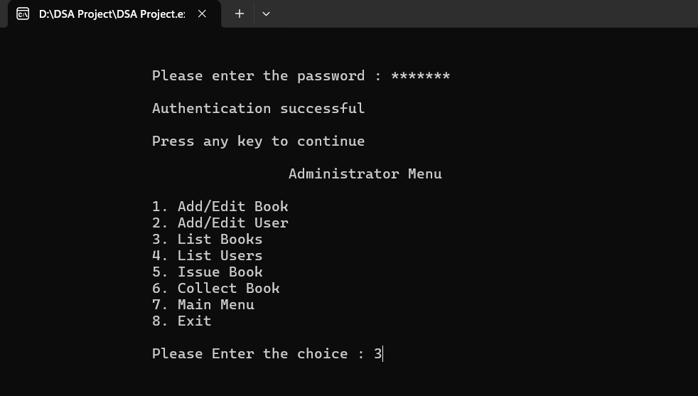
Figure 8:Authentication & Option Selection

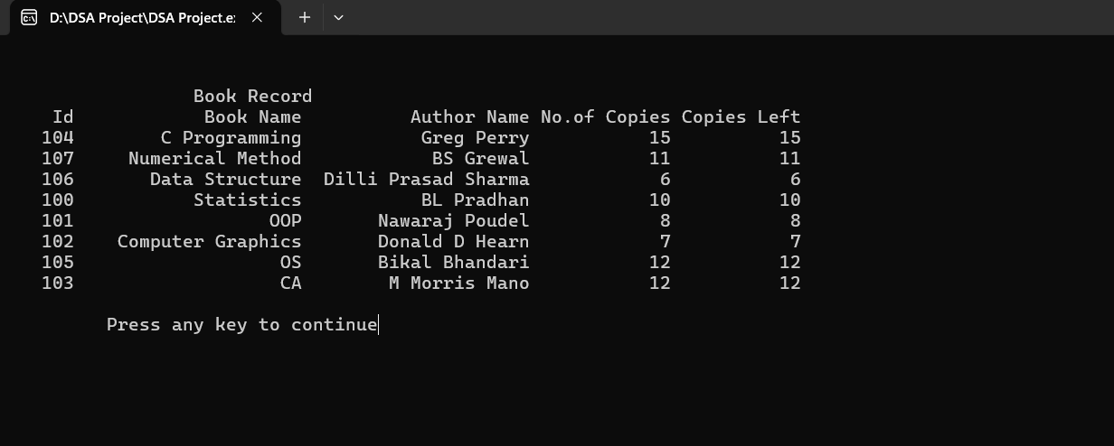
Figure 9:Book Record
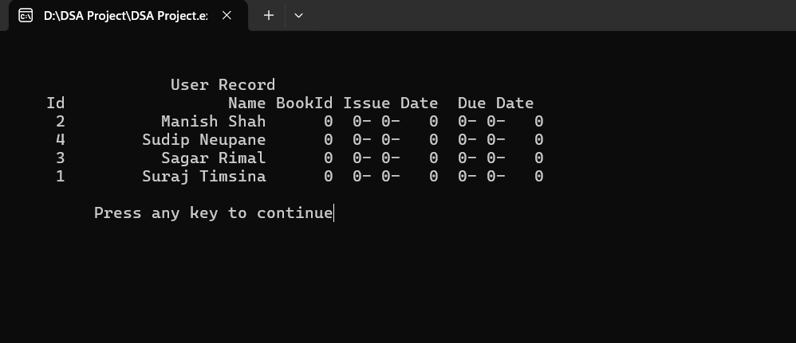
Figure 10:User Record
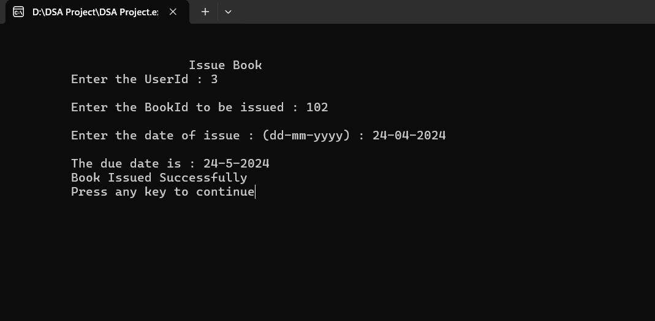
Figure 11:Book Issue

Conclusion
The Library Management Software offers a convenient solution for managing library resources efficiently. With features for book and user management, issuing, and returning, it simplifies library operations and enhances user experience.

Reference
1. ://www.academia.edu/25553795/Library_Management_system_Problem_and_its_Backround_Problem_and_its_Background
2. https://www.myeducomm.com/blog/importance-of-library-management-system

